What is the result of deducting liabilities from assets?

equity  
  
What are considered the knowledge and technical know-how of a certain position of the company?

Requirement

What is the interconnection of companies and their resources that link the supplier to the customer?

supply chain management  
  
What is the SCM process involved with converting raw materials into products?

production  
  
What are specifically the individual capabilities of an employee?

qualification  
  
What financial statement lets us know how much of the company is worth in total?

statement of financial position  
  
What are products performed called?

services

A friend of yours has purchased goods from you on credit. What SAP submodule would handle this transaction?

accounts receivable

What process attempts the prediction of the outflow and inflow of products?

forecasting

What is remuneration based on a month’s effort of the employee?

salary

What program is responsible for computing the

inventory and supplies of the organization and its

proper management?

Inventory

What financial statement shows us the current

expenses that the company has made so far?

profit and loss statement

What specific process refers to the managing sales

orders, supply and distribution hubs, and the

transportation of these orders?

order fulfillment

What refers to the collective technical resources and

health of the employees in an organization?

human capital

What is the SCM process involved with getting raw

materials?

procurement process

A friend of yours has purchased goods from you on

credit. What SAP submodule would handle this

transaction?

accounts receivable

What is accomplishing what is intended or wanted?

fulfillment

What specific process refers to the managing sales

orders, supply and distribution hubs, and the

transportation of these orders?

Fulfillment

It is a process of payroll processing that allows the

computation of each employee’s pay and notes the

errors in an error log. What may this feature of the

HR module of SAP be?

payroll processing

What concept is where we create the strategy of

replacing vital employees in an organization?

succession planning

These amounts refer mostly to the pay rate and

bonuses and are part of the computation of the

paycheck. What are these?

remuneration elements

What financial statement shows how easy the

company can use its liquid assets to pay off

commitments and expenses?

cash flow statement

What program is responsible for computing the

amount of raw materials to be bought at a certain

date?

Mrp

What involves the reporting, along with processes

before this, the monetary and non-monetary

information of businesses?

Accounting

What are composed of vehicles for the movement of

goods?

Transportation

What principle describes that if an account is

increases or otherwise, they must be recognized and

reported?

Accrual

What composes of plants or factories; and

warehouses or hubs?

Facilities

What is the creation of products specifically for the

distributors?

manufacturing flow management

These amounts refer mostly to taxes and

contributions and are part of the computation of the

paycheck. What are these?

statutory and voluntary deductions

A friend of yours has let you purchase goods on

credit. What SAP submodule would handle this

transaction?

accounts payable

What are products manufactured called?

Goods

What is the where certain processes of the business

are instead given to another company?

outsourcing and partnership

What concept refers to all sorts of things, with the

exception of people, that has value to an economic

organization?

Assets

What refers to the collective technical resources and

health of the employees in an organization?

human capital

You are a bookkeeper. Your company bought a new

computer for you to use and paid for it on credit from

the bank. What are the accounts affected and where

would their numerical values be placed?

equipment and accounts payable, debit and credit

You are a bookkeeper. Your company gave a loan to another company. What are the accounts affected and where would their numerical values be placed when you made a mistake and recorded the transaction twice in the journal?

accounts receivable and cash, credit and debit

You are a bookkeeper. Your company sold a new computer and the customer paid for it on credit from their bank. What are the accounts affected and where would their numerical values be placed when you made a mistake and recorded the transaction twice in the journal?

inventory and accounts receivable, debit and credit

You are a bookkeeper. Your company gave a loan to another company. What possible accounts are affected and where would their numerical values be placed?

accounts receivable and cash, debit and credit

1. **SAP CONFIGURATION**

**SAP S/4 HANA**

Is SAP’s current enterprise application suite

First released in 2015

successor to the R/3

Can be accessed via SAP GUI or SAP Fiori

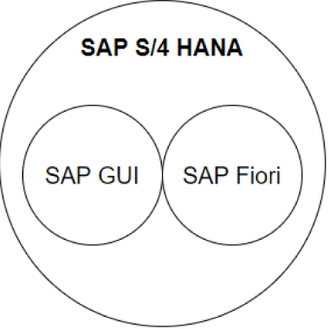

**SAP GUI**

universal client for accessing SAP functions

uses transaction codes for quick access

S**AP Fiori**

is a design system that enables you to create business apps with a consumer grade user experience

has search bars, dropdown menus to access apps

**Requirements for Connection**

**GUI:** sap router string, application server, instance number, system id, client

**Fiori:** https://<application server>.ucc.ovgu.de/sap/bc/ui2/flp

**On-premise**

traditional in-house IT infrastructure models

**Cloud**

**SAP S/4HANA Cloud:**

placing a customer’s instance of the solution on a partitioned cloud server alongside other customers

**Private Cloud:**

placing a customer’s instance of the solution on a partitioned cloud server alongside other customers

**RISE with SAP license:**

access to either an SAP S/4HANA Cloud or

SAP S/4HANA hosted on a private cloud

**Hybrid**

provides a combination of both on premise and cloud deployments

**Transactional Apps**

used to perform transactional tasks or entire business processes

**Analytical Apps**

provide role-based real time information about business operations

**Fact Sheet Apps**

provide key information and detailed facts of any business operation

1. **PROCUREMENT PROCESS**

**Procure**

To get, acquire

**Procurement**

is the business-to-business purchase and sale of supplies and services

Companies usually develop strategic plans with suppliers to support the manufacturing flow management process and development of new products

**Supply Chain Management (SCM)**

Is the network of services, material, and information flow that link a firm’s customer relations, order fulfillment, and supplier relations processes to those of its suppliers and customers

The web of people and organizations that connect goods and services together

**Procurement Process**

1. Choosing the goods and services required
2. Fill out a purchase request and request quotes from various suppliers
3. Work out a price and contract with the vendor, and complete the purchase order.
4. Receive the shipment and submit payment

**Outsourcing and Partnership**

Is an arrangement in which one company provides services for another company that could else be done or have usually been provided in-house

Benefit is that the company will increasingly focus on those activities in the value chain where it has distinctive advantage, and let everything else be outsourced.

**Financial Accounting (FI)**

deals in managing financial transactions within enterprises

**Logistic Execution (LE)**

deals with the complete supply chain process

comprising vendors, warehouse, production and distribution of products, and the customers

**Supplier Relationship Management (SRM)**

analyzing the supply of goods and materials by vendors to determine each supplier's contribution toward success and develop strategies

**SAP Production Planning (PP)**

consists of master data, system configuration, and transactions in order to accomplish the plan procedure for production

**SAP Materials Management (MM)**

manages materials required, processed, and produced in enterprises

where purchasing occurs

**Finance and Controlling (FICO)**

used for external and internal financial reporting, intending to record all financial transactions posted by an organization

**General ledger accounting:** concerned with managing all the general ledger accounts used for reporting

**Accounts receivables**: concerned with managing customer accounts and capturing all transactions with the customers

**Accounts payables:** manages vendor accounts and captures all transactions with vendors

1. **PRODUCTION AND FULFILLMENT**

**Production**

the action of making or manufacturing from components or raw materials

the process of creating new products

**Fulfillment**

the achievement of something desired, promised, or predicted

**Procurement**

the business-to-business purchase and sale of supplies and services

**Outsourcing and Partnerships**

is an arrangement in which one company provides services for another company

**Manufacturing Flow Management**

process is to produce and supply products to the distribution channels based on past forecasts or point of sales (POS) data must be flexible to respond to market changes, and they must accommodate mass customization

**MRP:** material requirements planning

**MRP:** a computerized program both to calculate the quantity of materials needed for production and to determine when they should be ordered or made

**MRP Il:** manufacturing resource planning

**Order Fulfillment**

responds to customer demand by merging several important functions: order management, storage, and delivery of finished goods

**Customer Service Management Process**

provides the source of customer information

provides the customer with real- time information on promising dates and product availability

**Forecasting**

seeks to predict levels of weekly or monthly product activity over time

**Facilities**

are the places in the supply chain network where product is manufactured, stored, or transshipped

The two major types of facilities are production sites (plants) and storage sites (warehouses)

**Inventory**

is the raw materials, work in process, and finished goods that belong to the company

**Transportation**

moves the product between different stages in a supply chain

**Information**

consists of data and analysis concerning facilities, inventory, transportation, and customers throughout the supply chain

1. **ACCOUNTING**

**Accounting**

is the measurement, processing, and communication of financial and non- financial information about economic entities such as businesses and corporations

is the measuring of organizations using money

**Assets**

anything that has current or future economic value to a business

**Liability**

any kind of financial obligation that a business has to pay at the end of an accounting period to a person or a business

**Equity**

is equal to total assets minus its total liabilities

**Balance Sheet**

an overview of a company's assets, liabilities, and shareholders' equity as a snapshot in time

**Income Statement**

covers a range of time

provides an overview of revenues, expenses, net income, and earnings per share

**Cash Flow Statement**

measures how well a company generates cash to pay its debt obligations, fund its operating expenses, and fund investments

**Concepts in Accountancy**

are a number of conceptual issues that must be understood in order to develop a firm foundation of how accounting works

**Accrual**

Revenue is recognized when earned, and expenses are recognized when assets are consumed

**Conservatism**

Revenue is only recognized when there is a reasonable certainty that it will be realized, whereas expenses are recognized sooner, when there is a reasonable possibility that they will be incurred

**Consistency**

Once a business chooses to use a specific accounting method, it should continue using it on a go-forward basis

**Economic Entity**

The transactions of a business are to be kept separate from those of its owners

**Going Concern**

Financial statements are prepared on the assumption that the business will remain in operation in future periods

**Matching**

This is the concept that, when you record revenue, you should record all related expenses at the same time

**Materiality**

Transactions should be recorded when not doing so might alter the decisions made by a reader of a company's financial statements

**Corporate Accounting**

involves the use, handling, and filing of a company's financial data often for the purpose of external reporting and tax compliance

**Public Accounting**

is to help ensure their financial statements, records, and filings are accurate

**Government Accounting**

work within the context of local, state, or federal government entities

**Forensic Accounting**

refers to a branch of accounting that collects, recovers, and reconstructs financial data when it is difficult or impossible to obtain

**Sales and Distribution (SD)**

records a sale and then creates an accounts receivable entry

**Materials Management (MM)**

controls purchasing and records inventory changes

The receipt of goods from a purchase order creates an accounts payable entry

**Financial Accounting (Fl)**

manages the accounts receivable and accounts payable items created in the SD and MM modules

**Controlling (CO)**

tracks the costs associated with producing products

**Human Resources (HR)**

manages the recruiting, hiring, compensation, termination, and severance of employees

**Asset Management (AM)**

manages fixed-asset purchases (plant and machinery) and the related depreciation

1. **HUMAN RESOURCES**

**Human Resources**

responsible for the activities to attract, hire, reward, train, and, occasionally, terminate employees

a company’s employees are its most valuable resource

**Human Capital**

consists of the knowledge, skills, and health that people invest in and accumulate throughout their lives, enabling them to realize their potential as productive members of society

**Human Capital Management (HCM)**

describe the tasks associated with managing a company’s workforce

**Recruiting Process**

describes the position, lists the qualifications a candidate must have, specifies the type of position (temporary, part-time, full-time, or internship), and states when the position will become available

**Interviewing and Hiring Process**

develops a short list of candidates

**Interviewing and Hiring Process**

1. If a candidate accepts the interview offer, the Human Resources Department makes the arrangements for the job candidate, including travel arrangements and a schedule of interview activities
2. The supervisor of the department in which the position exists also interviews the candidate, and other employees in the department are usually given time to talk to the candidate as well
3. After the initial interview process, a Human Resources’ staff member updates the candidate's file to indicate whether he or she is still a possibility for hire
4. Once someone in Human Resources Nas interviewed all the candidates on the short list, a representative of the Human Resources Department and the Supervisor of the requesting department rank the candidates on the short list
5. Once the candidate formally accepts the written offer, their file is again updated, showing that the candidate has accepted the offer
6. The Human Resources person then schedules a background check and drug test for the candidate, determines the employee's start date and makes plans for the new employee's orientation session
7. If no acceptable candidates were found, or if none of them accepts the job offer, then the process must be repeated, which at a minimum will require the development of a new short list but may involve starting over with a new job posting

**Human Resources Duties After Hiring**

1. The human resources department must maintain an ongoing line of communication with the employee and
2. his or her supervisor to make Sure the employee is performing well
3. Employee turnover can be a significant problem for a company
4. Another cost that is difficult to quantify is an employee's experience and job
5. Knowledge, which is lost when he or she leaves a company
6. Employee turnover is strongly tied to job satisfaction and compensation

**HR with SAP ERP**

A good information system allows human resources staff members to retrieve relevant employee information in a matter of seconds and to maintain proper controls so sensitive information is not compromised and privacy rules are not violated

**Human Resources (HR) module**

Provides tools for managing an organization's roles and responsibilities, definitions, personal employee information, and tasks related to time management, payroll, travel management, and employee training

provides an Organization and Staffing Plan tool that is used to define a company’s management structure and the positions within the organizational structure as a whole

**Person**

unique individual who holds a position and who performs tasks

**Tasks**

are assigned responsibilities related to a specific job or position

**Job**

general classification of tasks that are routinely performed together

**Position**

an individual employee assignment within the organization

Tasks can be assigned directly to a position, or they can be assigned to the position by assigning a job to that position

**Time Management**

Hourly employees, who are paid for each Nour worked, must record the hours they work so they can be paid

Salaried employees are not paid based on the number of hours worked, but typically their time must still be tracked

**Payroll Processing**

Employees are, not surprisingly, very particular about being paid the correct amount at the correct time

The process of determining each employee's pay is called a **payroll run**

SAP ERP system evaluates the input data and notes any discrepancies in an error log

**Remuneration Elements**

base pay, bonuses, gratuities, overtime pay, SICK pay, and vacation allowances the employee has earned during the pay period

**Statutory and Voluntary Deductions**

paycheck withholdings, including taxes (federal, state, local, Social Security, and Medicare), company loans, and benefit contributions

**Travel Management**

A travel request, which may originate with the employee or the employee's manager, is the first step in the travel management process

**Training and Development Coordination**

allows companies to plan and implement employee development and training activities that maximize an employee's ability to contribute to the organization

**Requirements**

are skills or abilities associated with a position

**Qualifications**

are skills or abilities associated with a specific employee

**Succession Planning**

outlines the strategy for replacing key employees when they leave the company or move to another position within the company

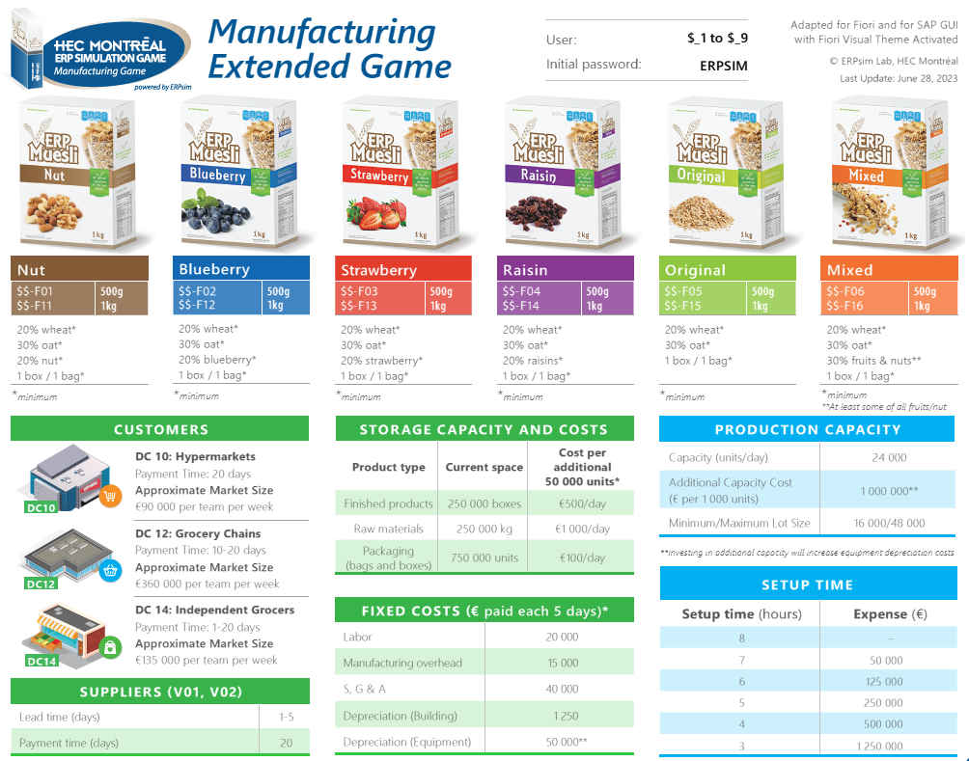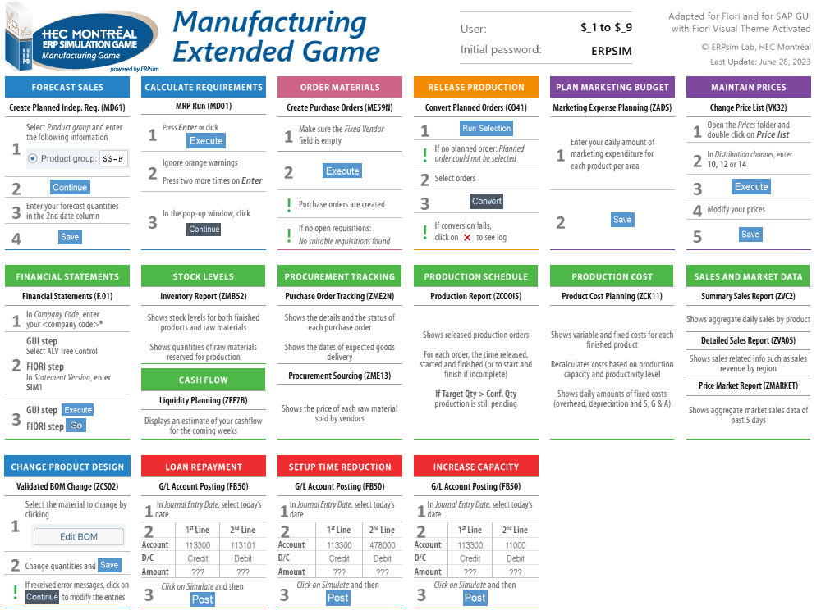

Create Planned Independent MD61

MRP Run MD01

Create Purchase Order ME59N  
Purchase Order Tracking ZME2N  
Convert Planned Order CO41  
Inventory Report ZMB52

Summary Sales Order Report ZVC2

Sales Order Report ZVA05  
  
create a flow chart from this concept (SAP ERP Simulator), use the symbols for appropriate use such as circle for start & end, parallelogram for input and output, rectangle for process, diamond for decision, document for data, and cylinder for database:   
Planning:   
Step 1. Create Planned Independent MD61   
Step 2. MRP Run MD01   
  
Procurement:   
Step 3. Create Purchase Order ME59N   
  
Monitor the Deliveries:   
Step 4. Purchase Order Tracking ZME2N   
  
As the Deliveries Arrived:   
Step 5. Convert Planned Order CO41   
  
Monitor the Finished Goods, Raw Materials, and Packaging:   
Step 6. Inventory Report ZMB52   
  
Check what products are the most selling:   
Step 7.1. Summary Sales Order Report ZVC2   
Step 7.2. Sales Order Report ZVA05   
  
and then repeat the process from Step 1. Create Planned Independent MD61. this time order the most selling products only.